**State the formula/equation for each of the following. Identify each part of the equation.**

1. Slope 2. Point-slope form 3. Slope-intercept form

4. Distance 5. Equation of a circle 6. Midpoint

**Find each of the following for each pair of points. a) Slope, b) Midpoint, and c) Distance.**

7. (0, 0) and (3,4) 8. (2, 5) and (6,3) 9. (0, 8) and (12, 3)

**Write the equation of each graphed line in slope-intercept form.**

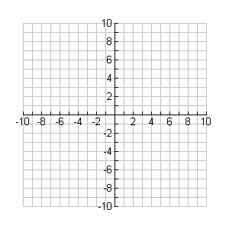

•

•



•

•



•

•

10.11. 12.

Eq. = ________________ Eq. = ________________ Eq. = ________________

**Identify the slope of the line that is a) parallel and b) perpendicular to the given line.**

13. a) b)

14. a) b)

**Identify the center and radius for each of the following.**

15. 16**.**

ctr. = _________ r = ____ ctr. = __________ r = ___

**Write the equation of each line in slope-intercept form using the given information.**

17. 18. (3, -1) and (-6, -4) 19. (0, 4) and (2, 3)

20.  21. Horizontal line through (6, 8) 22. Vertical line through (7, 10)

23. Parallel to  24. Perpendicular to $y=\frac{1}{2}x$ 25. Parallel to $y+1=-3(x-3)$

through (2, 3) through (0, 5) through (4, -4)

**Write the equation of the described circle.**

26. Center, radius  27. Center, radius  28. Center (0, 5), diameter 

29. Center (-6, 0), diameter 14 30. Tangent to the y-axis with center (3, 5)

31. Tangent to the x-axis with center (5, 2) 32. Center (-1, 3), point on the circle (-5, 11)

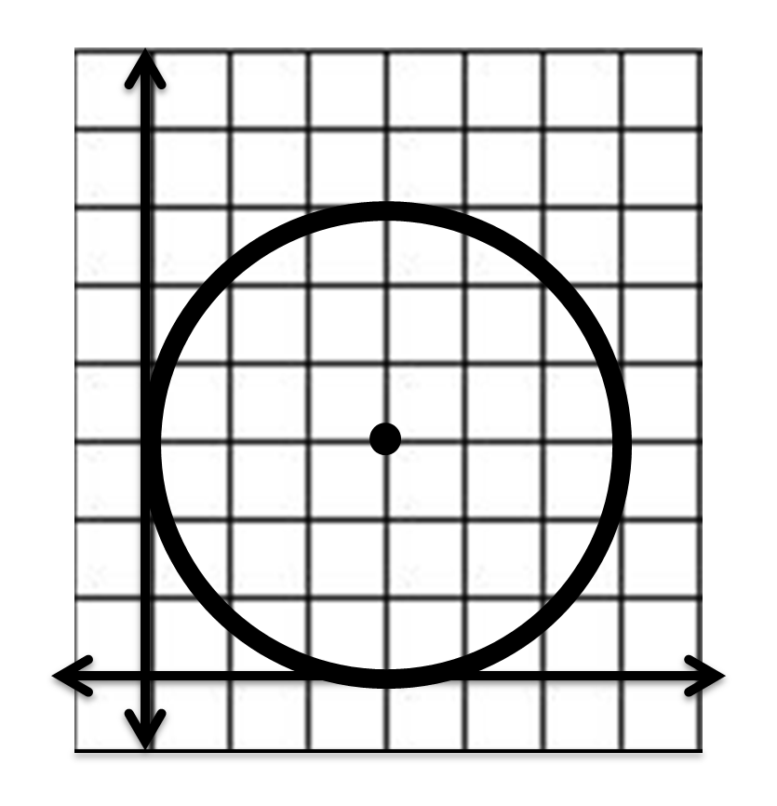

33.

34. Diameter with endpoints (4, 6) and (12, 12)

●